Website Design
Navigational Models
There are several different types of navigational models to consider.
Linear
All pages are contained on the same level. This is a simple model that users can navigate through quite easily. Works well for presentations or slide shows.
Hierarchical
A main page with links to subpages. Useful if your content can easily be split into categories.
Hub and Spoke
A single homepage that links to all other pages. All other pages then link back to the homepage. May be frustrating if one page relates to another but doesn’t link directly.
Full Web
All pages link to every other page. Slight risk of getting lost within the site but you are never more than a click away from the page you want to be on.
For my webpage I have decided to use a Hierarchical model. This way I can put all of my content into categories and make navigation of my site simple.

Paper Based Design
I plan to create a simple website with the navigation running down the left side of the page. I will create a banner to run along the top of the page that will be used on every page. I also plan to create something very similar for the page footer.
For the sites navigation I plan to have each link open a set of sub links below each button. These will drop down below the original button to make a sub link menu. The pages content will then display on the right side of the page.
Computer Based Design
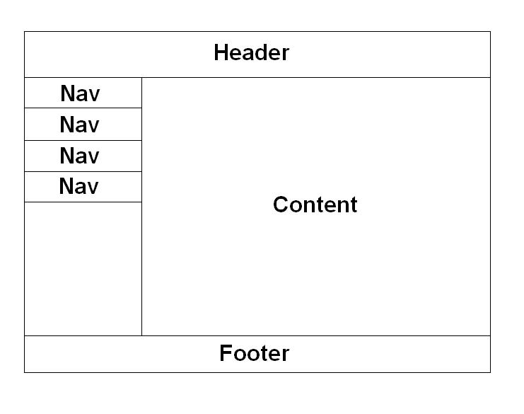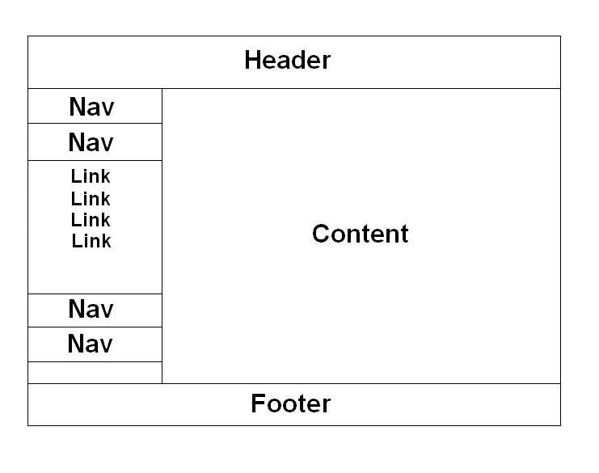

Wireframe
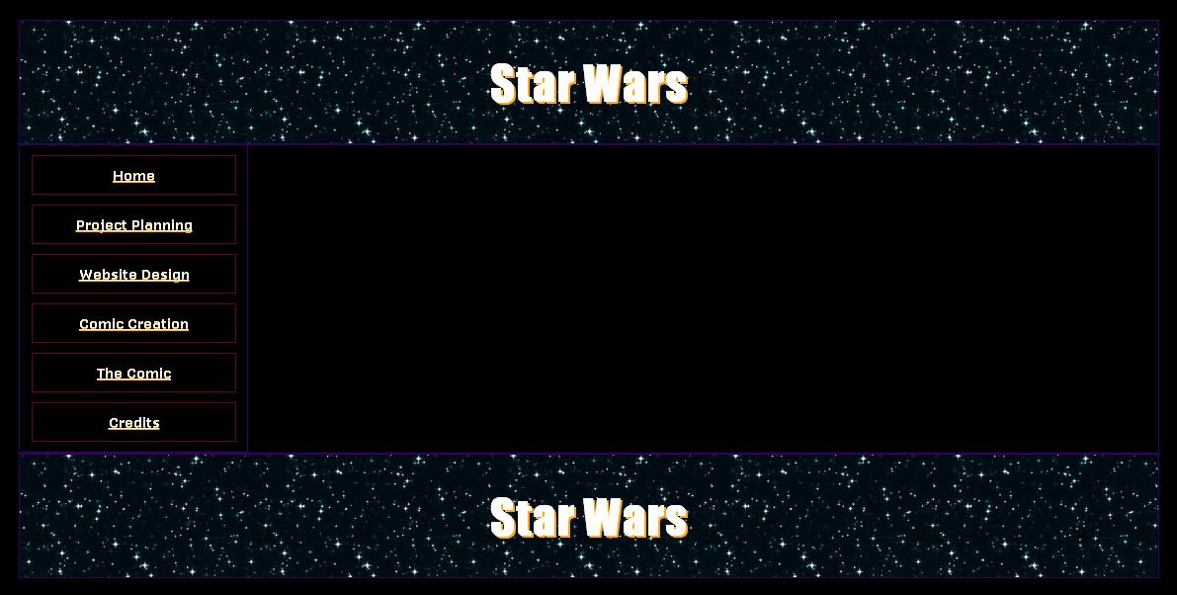
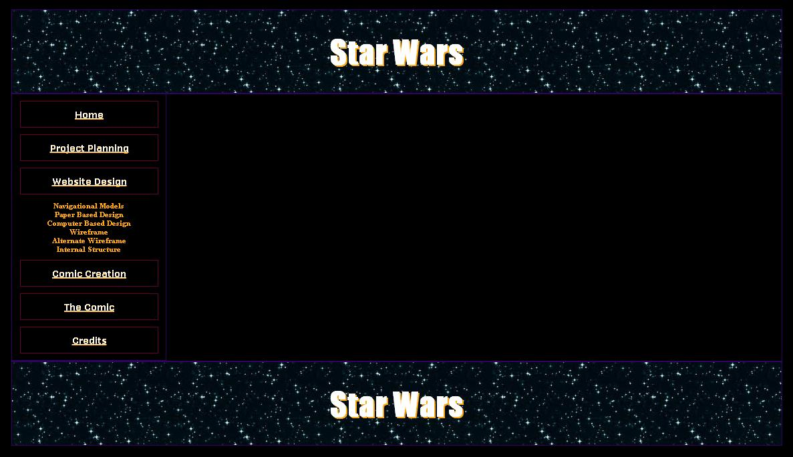

Internal Structure
The pages within my website will link together quite simply. Each category is broken down into sub pages and each button on the navigation opens a small sub menu.
Images used in the website are stored in an images folder for easy access and organisation during the web development stage.
All documents that I have decided to share from the website are stored in a documents folder and open in a new tab so that the site is readily available after a document has been opened in the web explorer.

